**Music Industry on Blockchain-based framework to protect Artist Royalty**

Akshat Anand(CSE with Big Data Analytics) ,SRM Institute of Science and Technology, SRM Nagar, Kattankulathur, , Tamil Nadu – 603203 [akshatanandmallik@gmail.com](mailto:akshatanandmallik@gmail.com)

**Abstract**-

A blockchain is an associate degree changeless time-stamped series record of knowledge that's distributed and managed by a cluster of the computer. Blockchain generation may have the transformational potential for those song industries associated with the recorded tune, and for the sustainability of tune careers. Blockchains could enhance the accuracy and availability of copyright data, facilitate near‐instantaneous micropayments for royalties, and significantly improve the transparency of the cost chain inside the music industry. Blockchain provides legal assurance for the creativity of the musician by the help of smart contracts but piracy can’t be stopped entirely. Blockchain framework can be used to create a distributive, transparent ledger device which will be public and permanent for the new records on sales, by tracking digital use and bills to content creators, such as musicians or the independent artists. Ethereum co-founder Joseph Lubin and Jesse Grushack founder of UJO Music is a blockchain music distribution start-up. The blockchain platform of Rights share provides freedom to artists/creators to handle its activities and streaming/viewing revenues from its own numbers so they can be received immediately.

**Keywords**- BLOCKCHAIN, SMART CONTRACT, ETHEREUM, MUSIC

**Introduction**-

Now a day’s music industry is growing rapidly. Due to growing internet connectivity music is being reached to each part of the world. As a result, many problems are generated like the illegal download of music, the royalty of the artist is endangered. Even though music industry is flourished still artists don't get proper benefits. To provide fair benefits to the music creators and companies can use blockchain. This is so because the artists put a lot of effort into writing or creating music but earn little from their works. Music copyright can be scored by digital marking or watermarking and therefore the blockchain technology and smart contracts proved to be most efficient methods to protect artist’s income rights. Blockchain is a public ledger transaction that can be seen by everyone on the network. Because of smart contracts payment and distribution can be operated without any control from a central authority. Smart contracts include details of stakeholders too. This information can be viewed by all. As a result, any unauthorized collection of fees by intermediaries can be avoided so payments can be easily tracked. Smart contracts help in governing important and valuable information about music and payments. Composers and artists will no longer be required to go through purchasing platforms and financial brokers. Based on blockchain technology the platform will enable direct the payments of the artist. Artist will have on how their song and data circulate among fans and other musicians. Blockchain provides much more transparency in the music industry which would generate more revenue and create more opportunities for the decentralized and distributed platform. Blockchain gives undeviating access to contents by removing the middle man. Blockchain records are secured by cryptography and in this paper, the protection of copyright of music by blockchain and smart contracts is discussed.

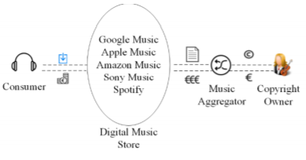

**Traditional Process of Royalties Distribution**

**Methods and materials**-

There are two kinds of users on the Blockchain network: Users and Musicians. Musicians can upload their musical works on the network and they earn royalty payments from fans automatically. The second user can search and pay for a musical work they like, and get permission (from various methods) to listen to music. The main categories are

Watermarking/Copyright- it sets digital information into digital media to track and reveals copyright owner through the help of vector quantisation method.

Encryption of audio-use of AES (Automatic Encryption Standard) algorithm to encrypt the music file to the database system to prevent illegal download, before uploading the song to IPFS platform.

Uploading Audio File to IPFS – it uses the IPFS platform as our external distributed storage, when we upload a file on the system it returns a hash code which can retrieve the file later.

Smart contract for music - uses smart contract which defines operations for copyright parameters and functions that are used to distribute payment. When a musician publishes a song, the system will call that smart contract on their behalf, input parameters to the contract and register the contract in the blockchain.

The Distributed Royalty-When the music publisher publishes the musical work to our platform, he needs to provide the copyright parameters. When a fan purchases the product the distributed royalty smart contract will be called which automatically sends royalties to the wallet address of the artist.

Music File Access Control - Copyright owners can use the access control mechanism to detect who has permission to listen to music. An access control mechanism is used for the audio file after it is purchased by fans to protect music copyright outside the blockchain. It uses the concepts and technology of Digital Rights Management (DRM). DRM consists of access control technologies which aim to control the copyright of work during the use and distribution process.

Versioning System - We use a Versioning System to update the data in smart contracts. The main idea of the Versioning System is to forward a function call to a new contract which is an update.

**The Blockchain Based Framework**

**Results and Discussion**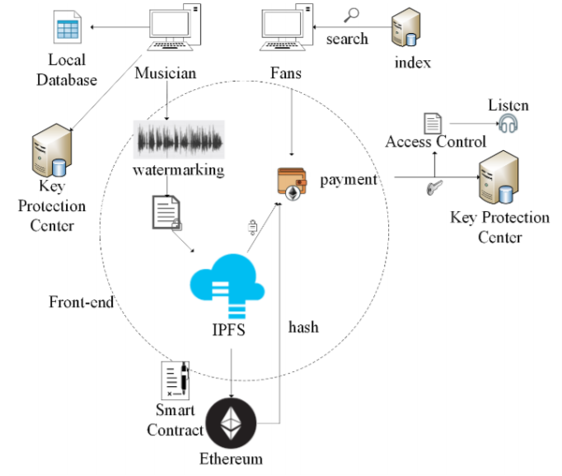

The above-enlightened technology we used the blockchain and smart contract technology to solve these challenges. All the present copyright rights of the users can be tracked in blockchain and people around the world can share the same copyright ledger in the public blockchain. The stakeholders can agree on the rules set by the smart contract which demand the set amount of royalties due to each participator. When the smart contract is deployed in the blockchain, these rules sync automatically, and then no one can change or reduce the royalties to others. Once the users/fans buy a song or a musical work on this network, musicians/stakeholders defined in the smart contract immediately receive their royalties as a token after the transaction is confirmed by the public blockchain.

Generally seeing the companies like Ujo, PeerTracks etc. are lacking the tracking of copyright protection of the music, in order to optimize the problem we can deploy special methods to track the copyright protection by watermarking techniques ( vector quantization method) and also for online listeners, we can also use control access to manage the expiry date of the music. When the user listens on the player the expiry date can be detected and hence the fan cannot access the file after the expiry date.

**Conclusion-**

Blockchain creates a bridge between artists and fans. It is a distributed database that records all transactions that have ever occurred in the network. Ethereum provides the platform to the blockchain. The payments can be transferred by the use of cryptocurrencies and tokens like ERC20 format tokens, which can be used by smart contracts. Every artist has their own token which they can distribute among their fans for buying the particular music. Payment can be done in real-time by adjusting the ledger. Watermarking and expiry date issued to the specific music files helps the illegal transfer of music files. Various companies work on particular technology with their flaws have been discussed with their solutions.

***References***

1. P. Galuszka. Music aggregators and intermediation of the digital music market. International Journal of Communication. 254–273, 2015.
2. Juri, M. The blockchain phenomenon – the disruptive potential of distributed consensus architectures. ETLA Working Papers 38, The Research Institute of the Finnish Economy, 2016.
3. Vitalik, B. A next-generation smart contract and decentralized application platform. 2013. https://github.com/ethereum/wiki/wiki/WhitePaper.
4. Joost, D. K. and Hans, W. Understanding the Blockchain Using Enterprise Ontology. 29–43. Springer International Publishing, Cham, 2017.